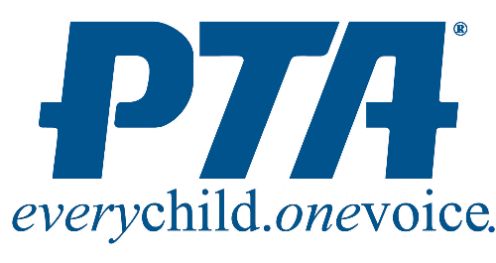
Emma K Doub Elementary School
Parent Teacher Association (PTA)
Membership Form 2018-2019

The EKD PTA supports many school programs including family activities, school and classroom volunteers, funding for supplemental classroom technology, supplies, field trips, fun activities, staff development and much more. We would love for you to join us!
Membership dues are $6 per person. ($4.25 goes to National and State PTA, $1.75 goes to EKD.)
Please complete the form below and send cash or a check (payable to EKD PTA) to school in an envelope marked PTA.

Name 1 _____________________________________________________

Name 2 _____________________________________________________

Email Address _______________________________________ Phone ______________________________________

Please Check One: __ Parent __ Student __ Teacher __ Other

Eldest Student’s Name ______________________________Grade _____Teacher: ____________________________

Home Address ___________________________________________________________________________________

Dues _______ ($6 X the number of members)

Tax Deductible Donation _______ (field trips, teacher incentives, school events such as winter wonderland, etc.)

Total Due _______

A membership card will be provided to all PTA members. Thank you for being a part of the Emma K Doub PTA!

----------------------------------------------------------------------------------------------------------------------------------
Please keep this bottom portion so you always know how to contact the EKD PTA

Email: ekdpta@gmail.com

Facebook: Emma K Doub PTA

***NEW THIS YEAR!! Stay connected with the EKD PTA using the Remind App. There are 2 ways to join us on the app:
1)Text the message @emmakdo to 81010
2)Email emmakdo@mail.remind.com

