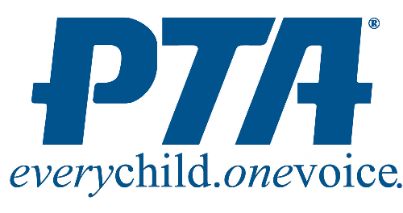
Emma K Doub Elementary School
Parent Teacher Association (PTA)
Membership Form 2015-2016

Join the PTA to create communities of active multicultural members dedicated to the educational goals of the school. The PTA advocates and raises funds for special programs and staff resources necessary to provide an equitable, outstanding education with enriched opportunities for EKD students. We are all in this together; please support the PTA.

EKD PTA supports many school programs including family activities, school and classroom volunteers, funding for supplemental classroom technology, supplies, field trips, fun activities, staff development and much more!
Membership dues are $6 per person. ($4.00 goes to National and State PTA, $2.00 goes to EKD.)
Please complete the form below and send cash or a check (payable to EKD PTA) to school in an envelope marked PTA.

First Name _________________________________________ Last Name ___________________________________

Email Address _______________________________________ Phone _____________________________________

Please Check One: __ Parent __ Student __ Teacher __ Other

Eldest Student’s Name ____________________________ Grade _____ Teacher: ____________________________

Home Address __________________________________________________________________________________

Dues _______ ($6 X the number of members)
Tax Deductible Donation _______ (field trips, teacher incentives, school events such as snowball dance, winter wonderland, etc.)
Total Due _______

A membership card will be provided to all PTA members. Please return this form to your child’s teacher, or drop in the PTA Box in the front office no later than Sept. 30th. For questions, please email ekdpta@gmail.com

----------------------------------------------------------------------------------------------------------------------------------

Please let us know your areas of interest…..

___ Winter Wonderland Event (Dec)
___ Game/Sports Night (Oct)
___ Walkathon (October)
___ Spring Book Fair (April/May)
___ Box Tops (all year around)
___ Teacher Appreciation Week (May)
___ Buddy Reader w/ students
___ Math Facts Helper
___ Technology Helper
___ Teacher Helper (copying, bulletin boards, cutting, etc)

Thank you for supporting Emma K Doub Elementary School PTA!

